**FULL-STACK WEB DEVELOPMENT CAT - 1 PROJECT**

**TEAM MEMBERS:**

K P NITHISH KUMAAR - 1934026 V L HARISUDHAN - 1934010

**PROJECT TITLE:** TRAVEL TICKETING

**WEBSITE NAME:** ATLAS

# Overview of the project:

Our project is based on developing a website for reserving tickets to travel through airways, roadways, and railways. Basically, we have a login and sign page for the customers who are in need of booking tickets for their travel convenience with the available mode of transports. The customers can search for the availability of the tickets based on the destination, date, time, and class. Finally, the payment can be done and the reservation can be confirmed. The transport modes features are mentioned below.

ROADWAYS:

* 1. Roadways include AIR buses, deluxe buses with and without AC, and sleepers and semi-sleepers.
  2. Roadways connect the cities in Kerela, Andra Pradesh, Telangana, Karnataka, and Pondichery from Tamil Nadu.

AIRWAYS:

1. Airways include flights to all the countries from India. The available classes are economy, business class, and premium economy.

RAILWAYS:

1. The railway’s ticket booking resembles IRCTC.
2. Railways connect all the major cities in India. The available classes are Sleeper Class, Third AC, Second AC, First AC, Second Seating, AC Chair Car, First Class, Third AC Economy.

Our main objective is to serve as a travel ticket booking agent and provide the service to the customers to reach their destination safely and happily.

# Navigation

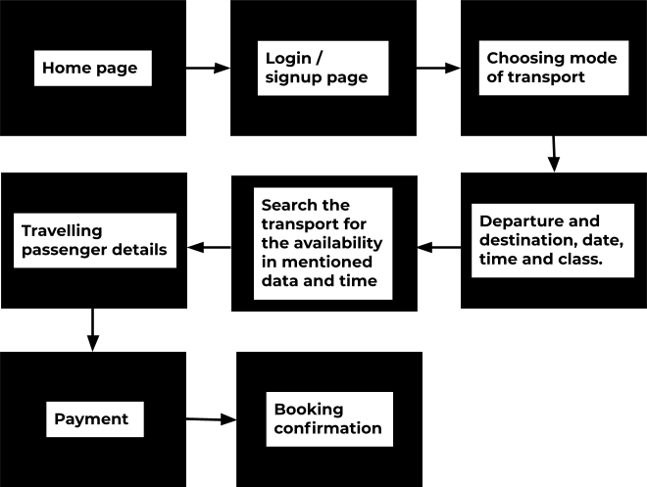

The above diagram explains the complete tour of our website to book tickets.

# Forms

Our website requires 4 forms as mentioned below.

* 1. Sign in and log in.
  2. Travel details - Departure place, destination place, time, date, and class.
  3. Passenger details.
  4. Payment